**Liquid Marble Wallpaper in Pink and Gold: A Blend of Luxury and Charm**

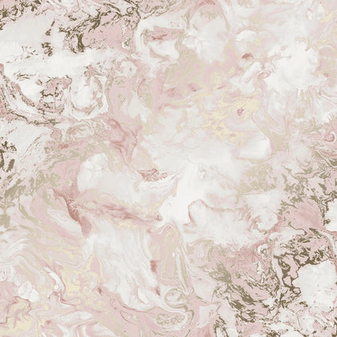Liquid Marble Wallpaper in Pink and Gold offers a perfect combination of elegance and warmth, making it a captivating choice for interior spaces. The soft pink hues exude a sense of serenity, while the luxurious gold accents add a touch of opulence and sophistication. Its fluid, marble-inspired patterns create a dynamic yet harmonious aesthetic, ideal for feature walls or accentuating specific areas in living rooms, bedrooms, or even boutique spaces. This wallpaper is not just visually appealing but also durable and easy to install, making it a stylish and practical addition to any decor.